13 Saving a Pose to the Pose Asset Library
11/30/2026
The clean Blender way is to save it in a Pose Library / Pose Asset:
- Keep Awedae in the exact problem pose you have now.
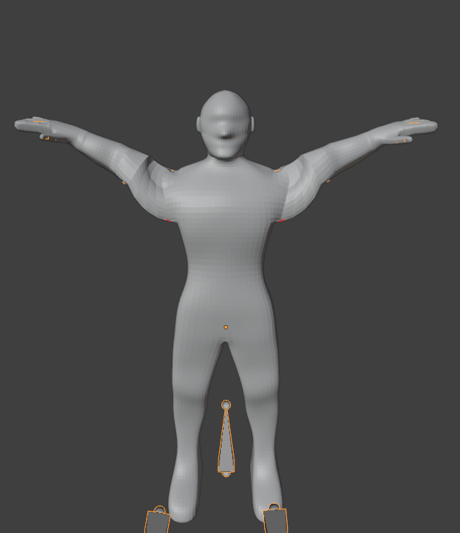
- Go into Pose Mode.

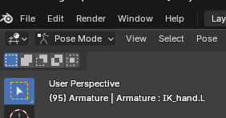

- Select the bones/controllers that define the pose. For our test, I’d select the whole armature with A, because we learned that leaving out something like the shoulder or pole can change the result.
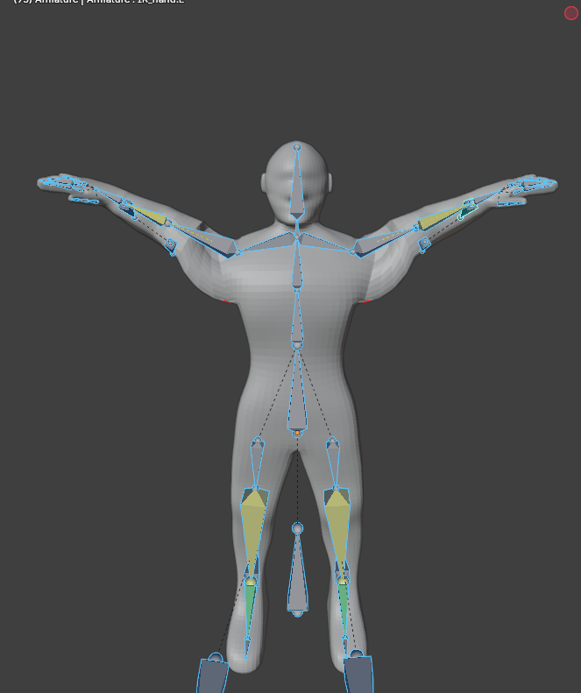
- Use Blender’s Pose Asset system to create a pose asset from the current pose.
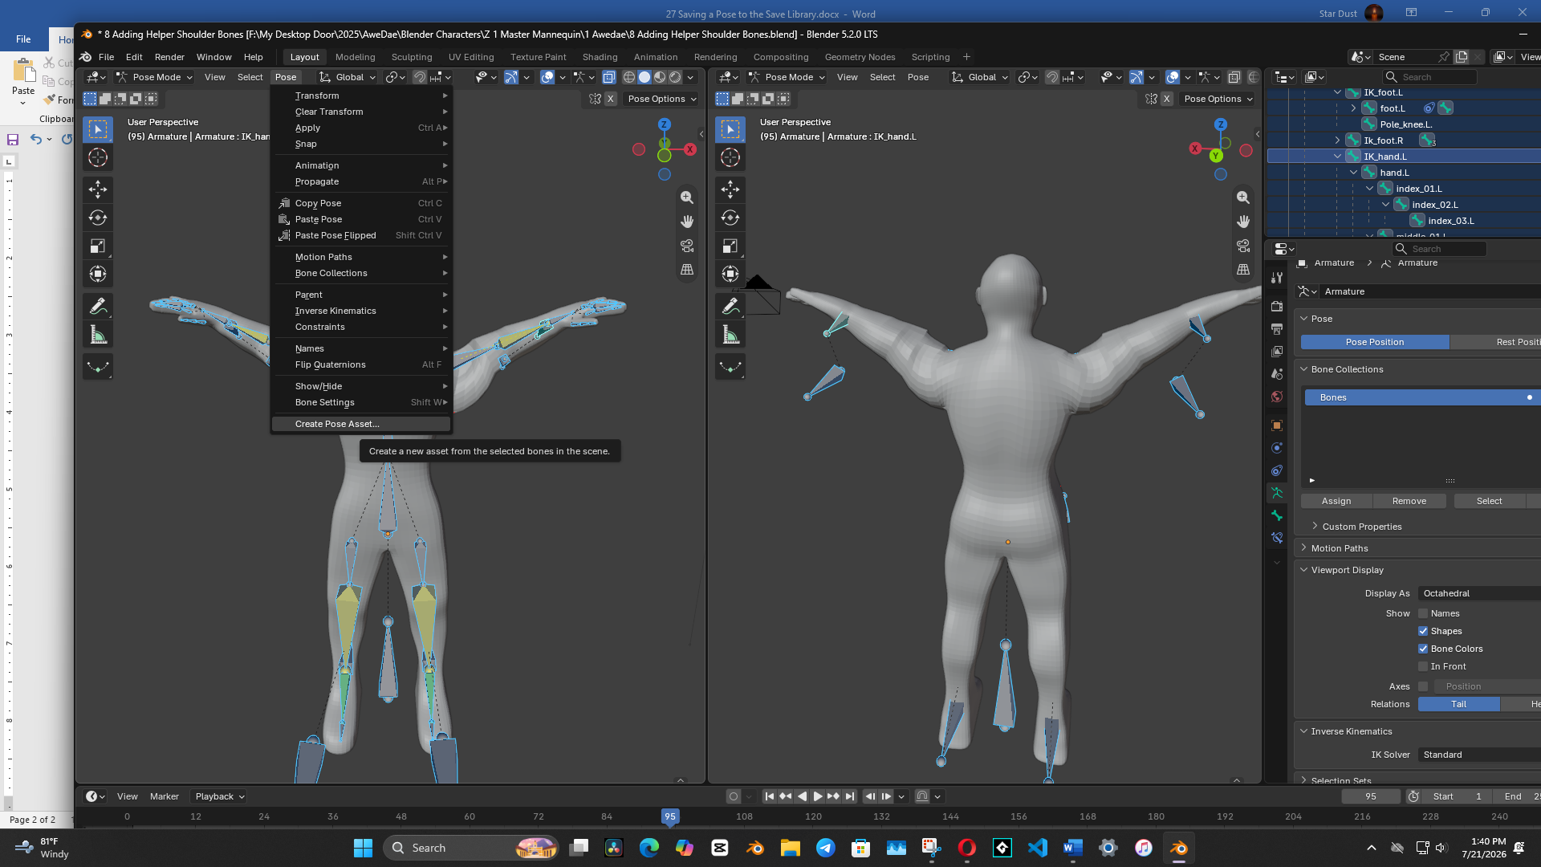

- Name it something obvious, such as Shoulder Stress Test or, in proper Grandma terminology, Worst Shoulder Pose. You can put something Like ‘My Poses’ in the Catalog box.
Watch it – Fill in everything, Blender will give you a heartache, if you try to make changes later.
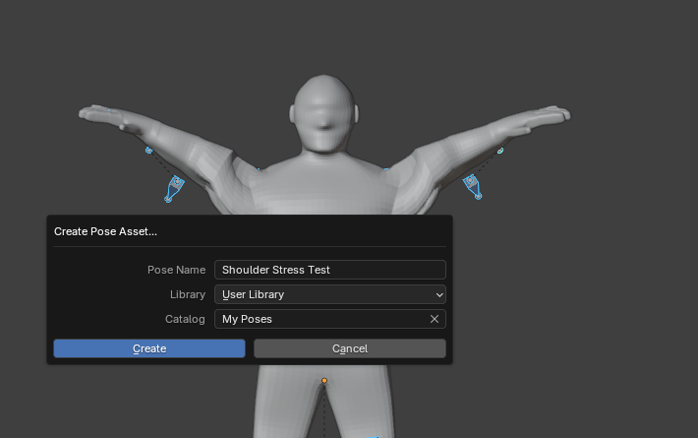
Hit CREATE to create the Asset

Then you can return Awedae to his rest/default position, and do what you need to do.

How to access the library when you need the Pose
Go to Top left of Blender Interface and Open that little thing that looks like books on a book shelf icon.
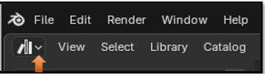
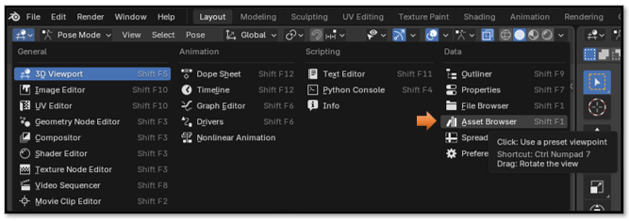

Change the drop down at top to be User Category instead of All Libraries.
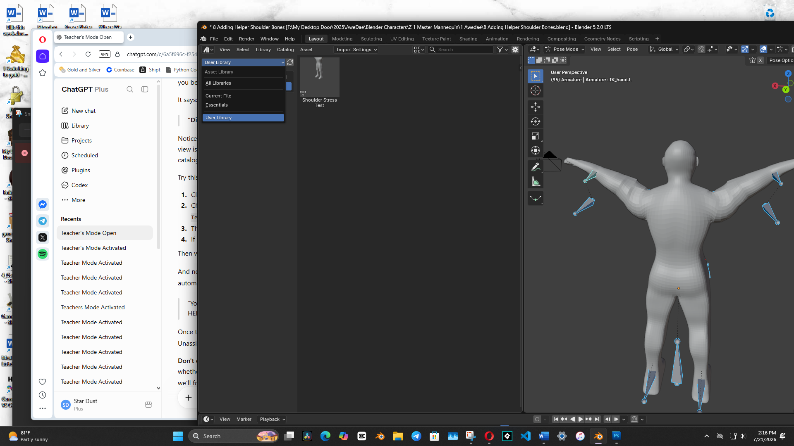

Later, find it under Asset Browser → User Library → My Poses.

